Style 3 – Document title

[d mm yyyy]

Prepared for:

Name
Job Title
Company name

(insert their logo here with any white background removed)

Prepared by:

Your Name
Job Title
translate plus

2 Television Centre, 101 Wood Lane
London W12 7FR, UK

Contents
Heading 1 3
1. Heading 2 3
1.1 Heading 3 3
Heading 3 – NO numbers. Use this heading when you want to add a title with no numbers or highlight a certain phrase. 3
Arrows 3
Images 3
End signature 3

Use Address style here. This is where your opening statement will go including who the proposal is prepared for, who wrote it and how to contact them. Make sure all e-mail addresses are a hyperlink. E.g Max.Bayley@translateplus.com

Heading 1
This is the largest heading and we would normally only use this on the front cover.

Heading 2
Use this heading for all section titles in your proposal.

Heading 3
Use this as your sub-heading. All numbers will automatically populate themselves so you don’t have to write any yourself.
- Use for bullet points.
- Use for numbered lists

Heading 3 – NO numbers. Use this heading when you want to add a title with no numbers or highlight a certain phrase.
You can still add bold, italics or underline manually.

Arrows
Make sure you have covered the top-left arrow on the first page and the bottom-right arrow on the final page with a white box.

Images
If you need to add an image you must make sure that the image does not go over 15.2 cm, so that it is in line with the text margins. Make sure your image is using the text wrap style of Top and Bottom so that you can use your keyboard arrows to position it.
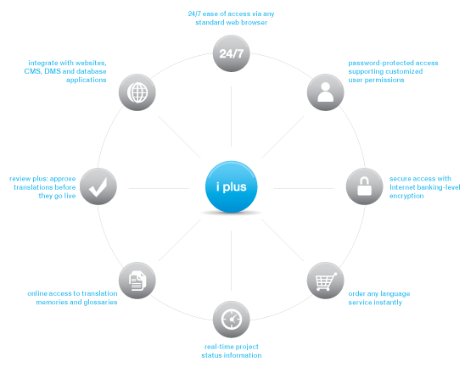
If you add the i plus diagram, please make sure to use the one saved in the Proposal template folder, as it has a transparent background. See below. If your image is the first thing on a new page, make sure it starts below the arrow on the top-left of the page.

End signature
If you add a “sign off” to your proposal, use the end signature style for your details, e.g.:
Your Job Title
Your Tel: +44 (0)20 7324 0950
Your E-mail: Max.Bayley@translateplus.com

- Make sure to check your final PDF version!
- If you are using a language other than UK English, select all (Ctrl+A) and set the language of the document as needed, so that you can spell-check the whole document
- Please send the proposal to Marketing for checking if time allows

